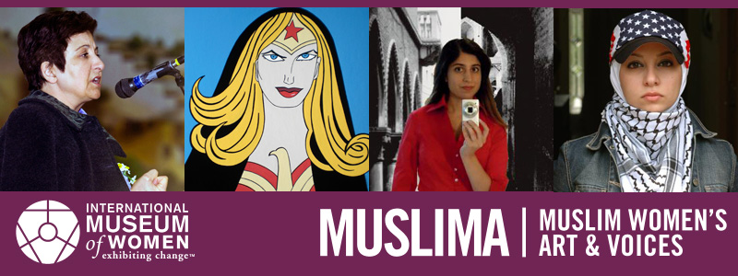
You’re invited to a Muslima discussion event
Explore the online “Muslima: Muslim Women’s Art & Voices” exhibition, discuss the issues with friends, and help fight against negative stereotypes.
[INSERT DAY], [INSERT DATE], [INSERT TIME]
[INSERT YOUR VENUE ADDRESS HERE]
RSVP to [Insert your email here]
Presented by the International Museum of Women, Muslima: Muslim Women’s Art & Voices is a virtual exhibition of groundbreaking thought pieces and artwork from contemporary Muslim women from around the world. Through their art, leadership, and community involvement, these women are defining their identities and, in the process, shattering pervasive stereotypes that persist about Muslim women. By changing attitudes, communities around the world can help to bring about a more just, equitable, and inclusive world.
Take part in a discussion about the issues explored in Muslima! Guests will explore selections from the Muslima exhibition and then engage in conversations about the issues. Be an agent of positive change in the world.
muslima.imow.org
www.imow.org

